**Search engine management platforms**

* **Consolidates data**, allows smartes decisions.
* Single Interface with better workflow
* **Optimization** : enfocarse en las metase de la campaña y aumenta la performance

**Steps del SEM Process :**

1. Advertisers bid on keywords
2. Search engines rank advertisers
3. The aadd with highest rank appears alongside search results

**SEM OFFERINGS FEATURES CHECKLIST**

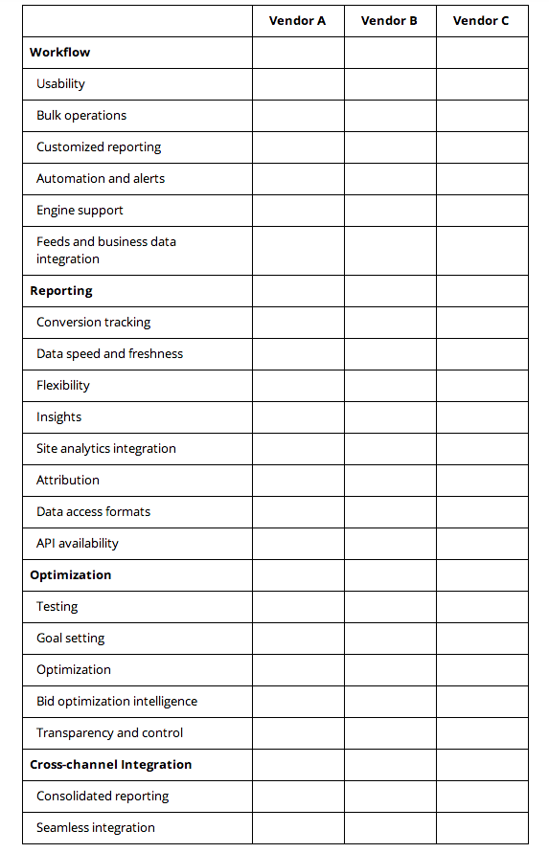

**Why and how we search and how to interpret the results.**

**What is Google :**

Google is a web search engine that's designed to allow users to search for information across the World Wide Web. Google's mission is to organize this information and make it universally accessible and useful.

**Online consumers most common habits:**

* They continuously search online
* They search in micro moments of insights when they desire something..
* They use devices on the go

**3 Main elements on a results page include**

* Shopping Ads
* Text Ads
* Organic Results

**Text ad components :**

* A catchy title — the “One Day Sale + Free Ship $25…” Its promotional pitch worked!
* A distinguishable identifier — the “Ad” box left of the ad title.
* A variety of ad extensions — multiple opportunities to give customers more reasons to click by way of sharing additional benefits and business offers. Here, we see shipping promos as well as links to specific pages in Maria's site.

**The 3 R’s of Google Search:**

* **Reach:** reach people when it matters, re engage with existing customers
* **Relevance:** match the message to what the user wants in that moment + creativity “want-to-know,” "want-to-go,” “want-to-do,” and “want-to-buy” moments
* **Results:** focus on outcomes and optimizing campaign according to them

**Find the right performance solutions :**

**The 3 steps in the online marketing process:**

1. **Define you campaigns goals and KPis associated to those goals**

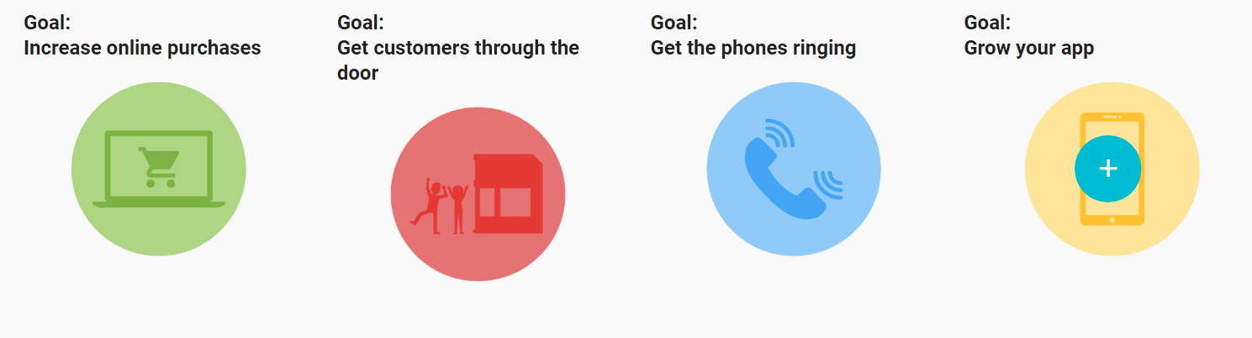

1. **Understand who your target audience is and where they´re located :**

* **Moments map :** identify most valuable moments that you need to win and secure, examine the phases of the consumer journey and the steps they have taken to reach to you.
* **Understand the particular moment :** are they asking questions, looking for information or researching ?
* **Use data to see where, when and how potential customers are searching**
  + Google Surveys, Google Trends, Shopping Trends, Google Correlate
  + Use this data to deliver different messages to seize those moments.

1. **Choose the ideal solution that drives your goals and targets your audience**

|  |  |
| --- | --- |
| **Drive action**  **on your website** | **-Use ad extensions to show more**  **-Add dynamic content based on location or current time**  **-Remarketing lists (RLSA)** |
| **Drive foot traffic**  **to your business** | **-Feature directions on google maps**  **-Location targeting based on your products**  **-Show stocks and prices**  **-Conversion trck to check if real sales relate to online ads** |
| * **Get the phones ringing** | **-Feature phone number in adds**  **-Call extensions**  **-Only show phone during uptime hours** |
| **Get people to use your app** | **- installs and re engagement** |

**Conversion Tracking**

Go back in time and see paths and interactions consumers took before converting, captures interaction through cookies without identifying the people but without sending the id

* **Allows to invest more in associated sites or content that drive conversions**
* **Allocate bids to placements that convert more or are related to stuff consumers search before converting**

**Examples :**

* See which creatives drive more sales
* Which type of users are more likely to sign up or buy
* When is people more likely to sign up or convert.

**Set up Conversion Tracking Source:**

* Website: See path taken before converting
* Apps : Completed actions in an app
* Phones : Tracking call mades
* Imports : Track when **an ad leads to a real store purchase or phone call.**

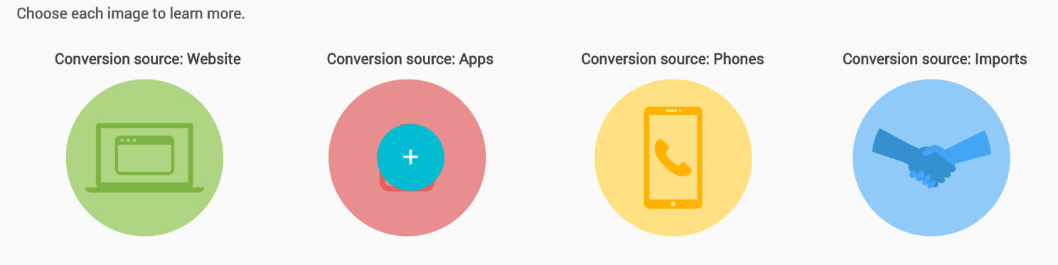

**Setting up conversion tracking, 4 steps:**

1. Create a conversion action, that what you want to track, install, download, a call.
2. Get a conversion tracking tag, code that tracks users actions on the source you set.
3. Add the conversion tag to your website
4. Check the conversion tracking is working as planned

**Understand your Audience**

**Google Surveys :**  For fast focus group data, test hypothesis for target consumer

* Probe for audience thoughts on existing or past campaigns
* Test consumer insights
* Uncover customer mindsets

**Google Trends** to find out recent trends

* Answer key brand questions
* Gauge consumer search behaviors
* Confirm hypotheses about audience interests
* Share audience interest over time
* **Google Shopping Insights** Understand consumer awareness and mindshare for a product, from national down to city-level insights; Insights is currently available for the US market only
* **Google Correlate** to uncover more nuanced insights about a trend she discovered on highlighting
* Find queries that follow a similar search pattern, thereby uncovering insights that might not otherwise be visible.

**Search Only Campaign**

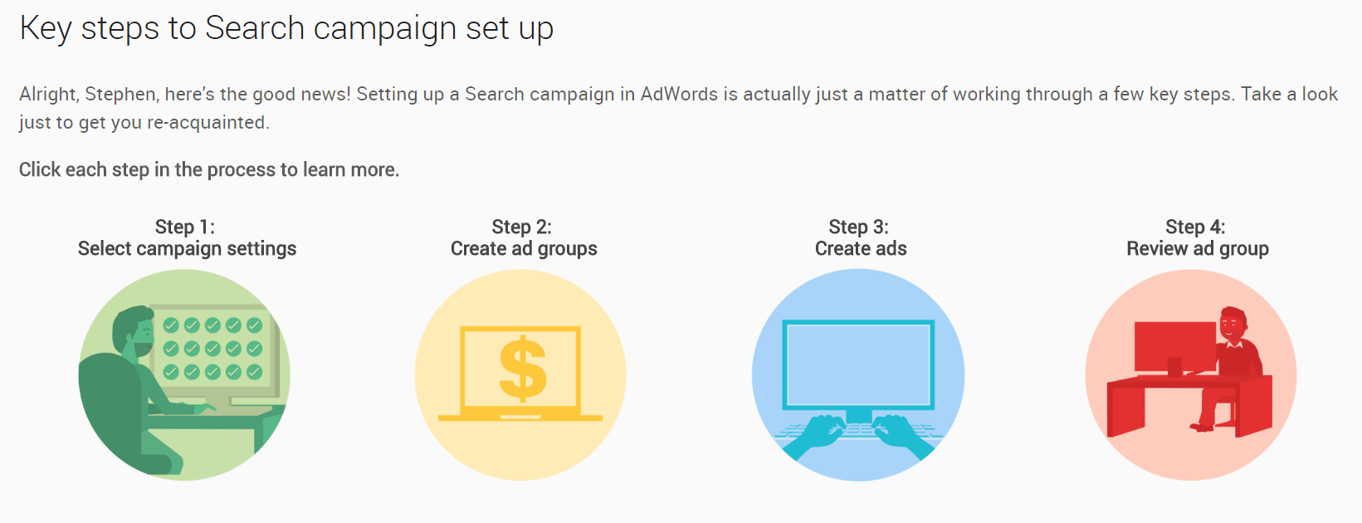

**Ad Group Statuses :**

* **Under review:** Pending
* **Approved:** Showing
* **Paused:** Temporarily stopped
* **Disapproved:** Not showing due to non-compliance with AdWords policy
* **Removed:** Disabled

**Campaign Optimization Strategies : 3 larger groups with subtypes**

**Ads and ad groups :**

* **Change your ad to get a longer, more noticeable headline**
* **Create more ads**
* **Add ad extensions (call, sitelink, or callout)**
* **Create new ad groups from existing ones**
* **Optimize your ad rotation**

**Keywords targeting and reach**

* **Add keywords and even negative keywords**
* **Broaden your keyword matches to include “phrase match” or “broad match”**
* **Target Google Search partners**
* **Power up for mobile**
* **Add audiences**

**Bids And Budget**

* **Raise your budgets to keep your ads running on your busiest days**
* **Use standard ad delivery to stretch out your limited budget**
* **Adjust bids in oh so many ways**

**Opportunities Tab :**

* **New feature that gives you insight on optimization opportunities**

**Other Tools :**

* **Bid Simulators :** campaign bid simulators, Target CPA simulators, bid adjustment
* **Campaign drafts and experiments**
* Add customizers so they adjust based on what is being looked and according to time or specific weeks
* **Get Reports Insight :** Search terms report, top movers report, auction insights report.

**87 percent of consumers research online before entering a store, but more than 90 percent of goods are still sold in stores**